Hi Parents,
As we all know by now, school is going to look very different until further notice. This is a situation that most of us have not ever endured during our teaching careers, but we ensure you that we will work together to continue the learning for our students.
The first-grade team has been working together remotely to come up with an instructional plan that will be both intentional and beneficial for your child.
We will primarily use my blog (https://mscoynesclass.weebly.com/) and SeeSaw for class updates. Please go ahead and download the SeeSaw CLASS app if you haven’t done so already, as this is going to be a great way for the students to post all of their learning.
Mrs. Paine’s virtual office hours will be from 8:30 – 10:00 each morning and Mrs. Davis’ virtual office hours 10:00 – 11:30 each morning. During this time, we will be available, via e-mail, to answer any questions you might have regarding the daily assignments. Daily assignments should take approximately 1.5 – 2 hours to complete each day. Please don’t forget that this is your child’s work. We want to see what they can do; however, please help them when needed!
Here is a sample schedule as we all know kids this age thrive on schedules and routines:
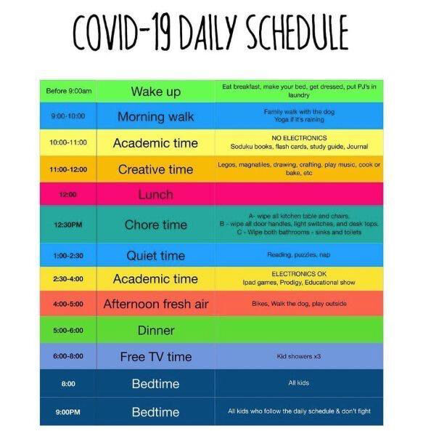
The district has communicated that although we cannot take grades, due to the level of independence, the work is expected to be done just as it would be in class. If work is not completed, it will need to be made up upon our return to school. Thanks for your support at home.
Please share the following message with your child:
We will miss seeing each of you every day! I will be posting assignments on SeeSaw for you to complete. Please work hard and try your best. Remember that we have high expectations for you and expect that your work is nice and neat, just like you would do at school . We will be giving tickets upon our return to students who put forth their best effort each day! The best part of all of this is that we all get to work from home in our pajamas, which is SO fun! We can’t wait to see your shining faces soon! Feel free to upload a video of yourself to SeeSaw to show me some of the fun activities you are doing at home! Hugs to you all!
Parents – Please complete this survey linked below by Monday, March 16th at Noon. I just need one parent from each household to fill out the form. Thanks for helping me understand how your child will be learning at home!
https://forms.office.com/Pages/ResponsePage.aspx?id=-x3OL5-ROEmquMR_D8kYLe015fjjFE1Lrn3FbmB6F59UNUNLRDZCMEI4TU81TUtSTlEyV1NOMDNDTi4u
The Remind App is another great way for us to communicate. Our messages will be sent to one another as text messages.
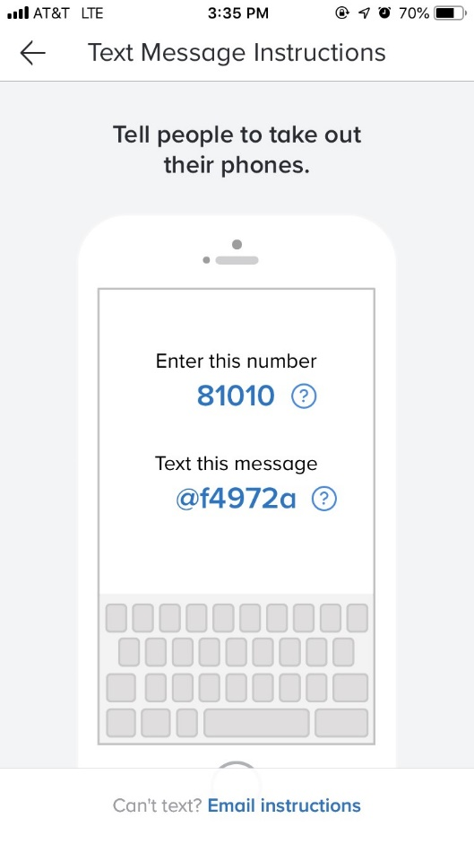

Directions for accessing resources at home:
- Clever Clever is the resource you will want to use most to access our digital materials.
  - This website will allow your child to access RAZ kids, BrainPop Jr., and MobyMax. Additional sites will be added as needed.
  - It takes the students directly to the website without having to type anything in. I also linked the SeeSaw homepage. They should be able to navigate this site once you log them into clever.
  - Once you log into clever, please click on M.Paine’s Page.
  - Here you will see RAZ Kids, BrainPop Jr., MobyMax, and SeeSaw.
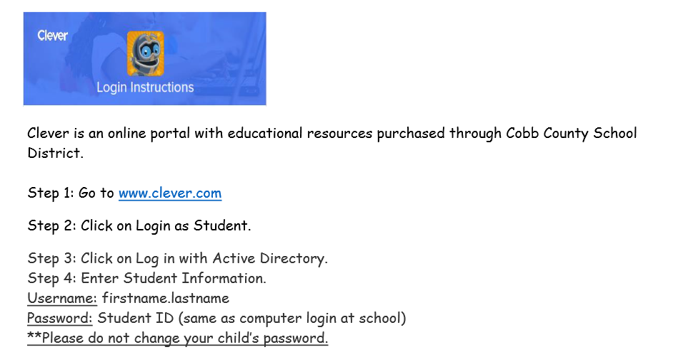
- Cobb Digital Library This allows students to access BrainPop Jr. and PebbleGo. 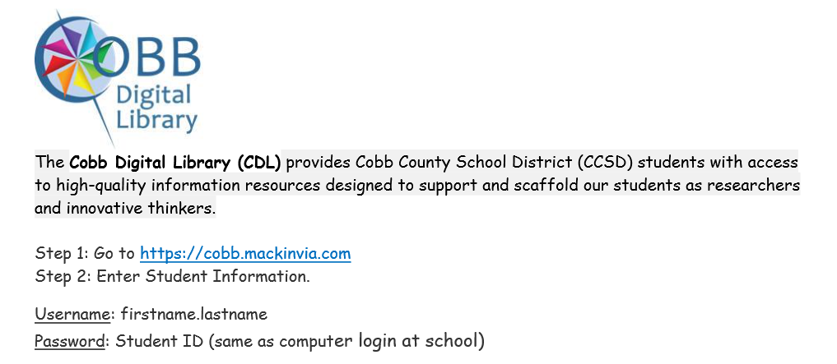

- Uploading/completing assignments on SeeSaw
  - Step 1: Log into your SeeSaw home learning account. Don’t forget you can access your SeeSaw home learning account through the SeeSaw CLASS app or through a web browser.
    - Go to https://app.seesaw.me/#/login or use the app on a device.
    - Click on I am a student.
    - Use the QR code or text code to sign-in.

  - Step 2: Click on the activities tab on the right side.
  - Step 3: Click on the activity you will complete.
  - Step 4: After completing the activity, click the green check marks to turn your work into your teacher.
  - Step 5: Your teacher will review your work and give you feedback!
  - Step 6: Happy Learning!

